Task 5: Create Storage Account with Blob and File Share
What to do:
Create a Storage Account and configure:
Setting | Value
Name | stnovatech{id}prod001
Performance | Standard
Redundancy | LRS (Locally Redundant Storage)
Blob container | company-assets (Private access level)
File share | it-department (Quota: 5 GB)
Upload a test file (any small file — a text file, image, etc.) to the blob container.
Acceptance Criteria:
- Storage Account exists with LRS redundancy
- Blob container company-assets exists with Private access level
- File share it-department exists with 5 GB quota
- At least one test file is uploaded to the blob container

Deploy a Linux Virtual Machine in Azure portal
- Sign in to the Azure portal.
- In the search box at the top of the portal, type Storage Account . Select Storage Account in the search results.
- Select + Create.
Enter the following values:
- Subscription: Select your Azure subscription.
- Resource Group: Select the previously created RG
- Name: Give the Network storage account a name.
- Region: Select an Azure location East US
- Performance: Standard
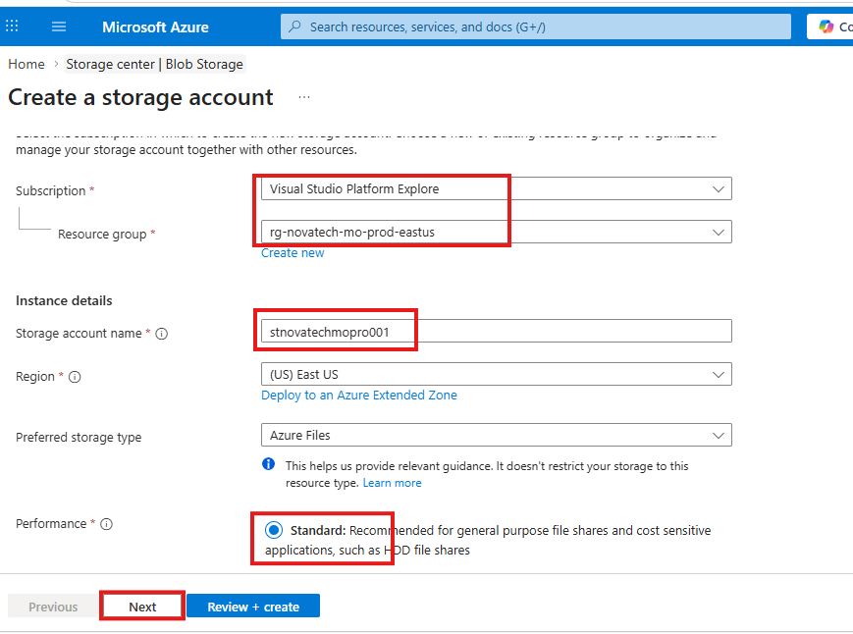

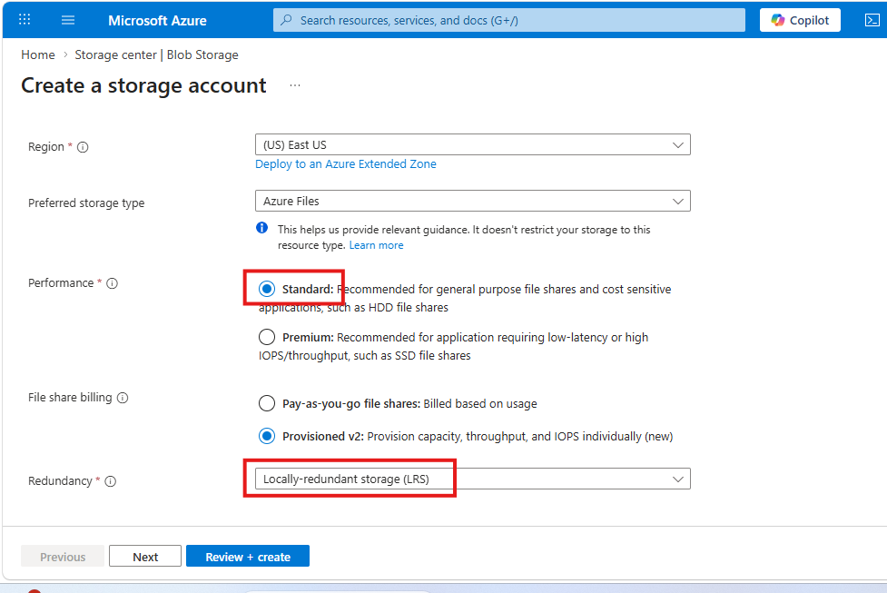

Click review + create to create.
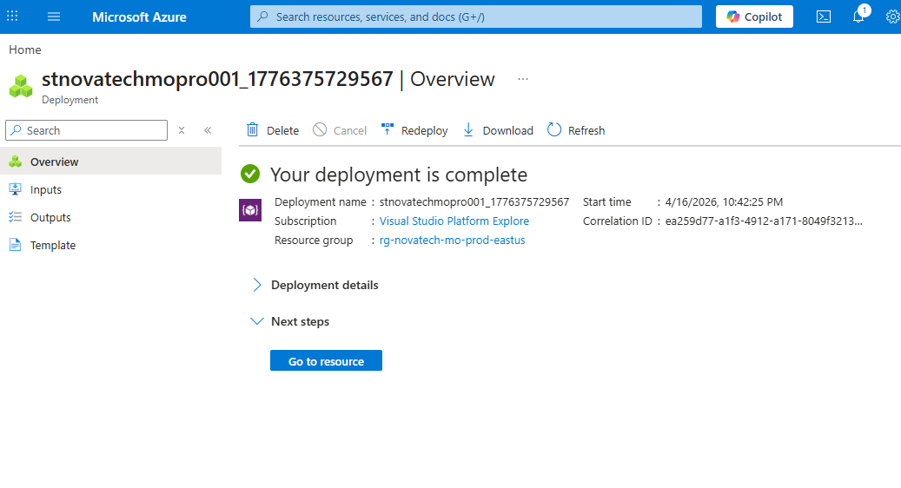
Blob container company-assets exists with Private access level
Open the storage account
Click on Data storage>> containers
Click on +Add container
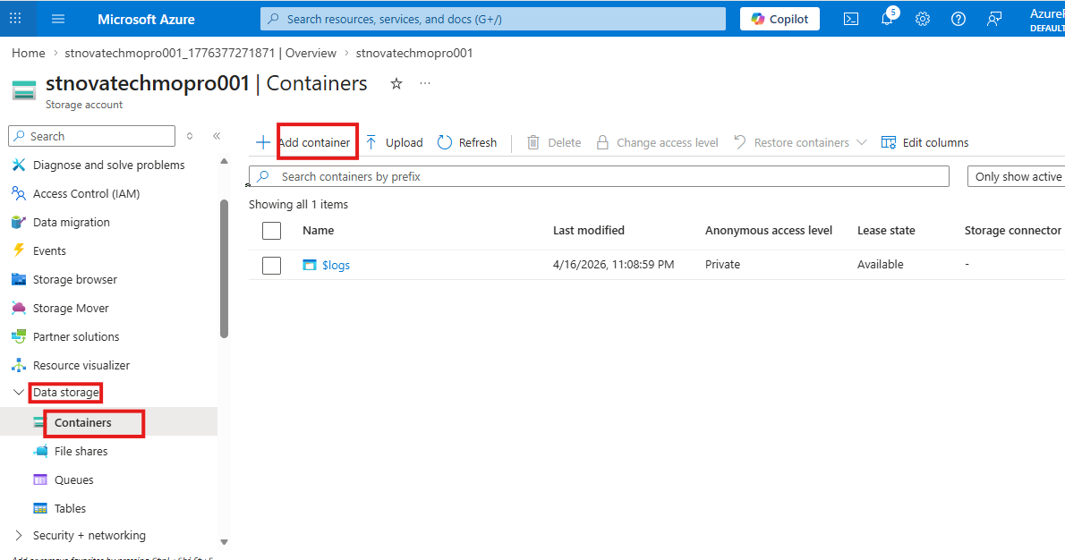
Container is Created
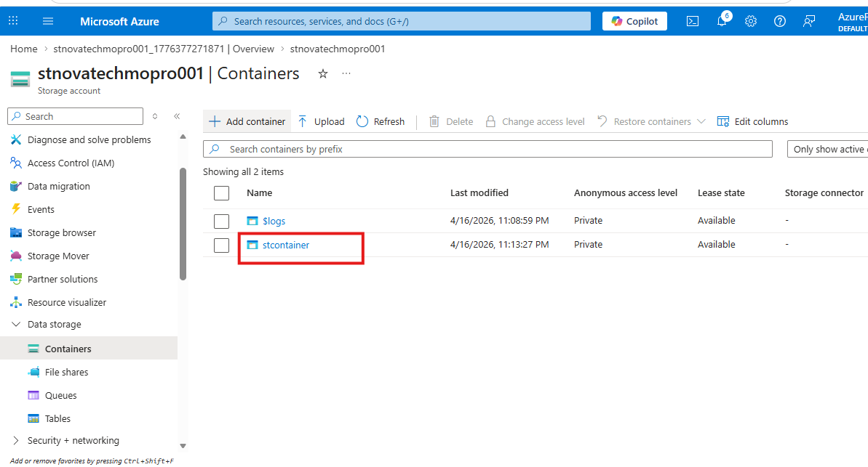

Click on the container to open
Click on +Add Directory to upload a file to the container
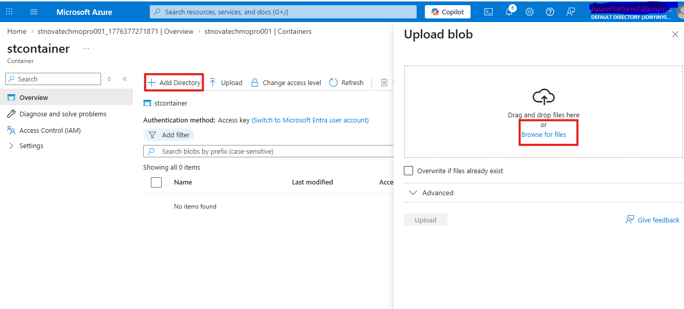
At least one test file is uploaded to the blob container
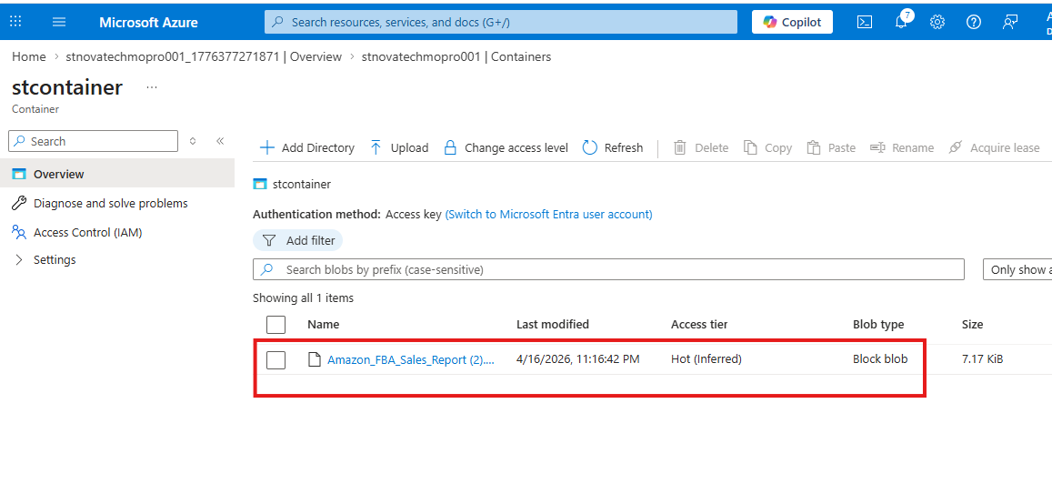

File share it-department exists with 5 GB quota
Click on Data storage>> File shares
Click on +File share
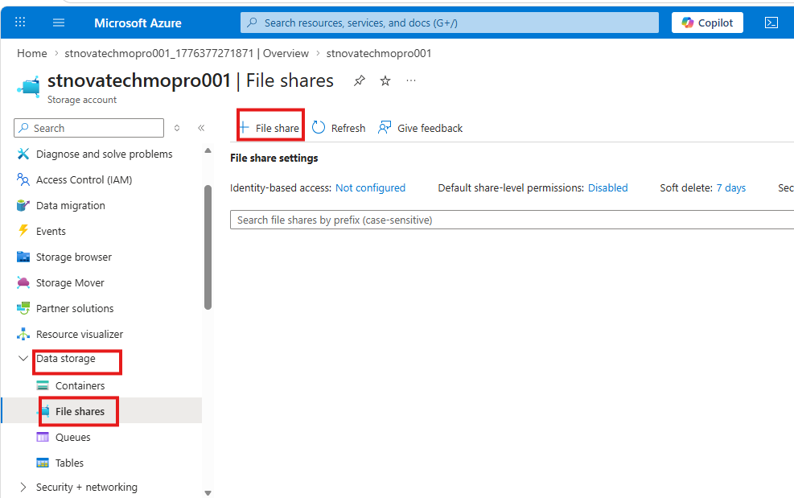
Click on review to create
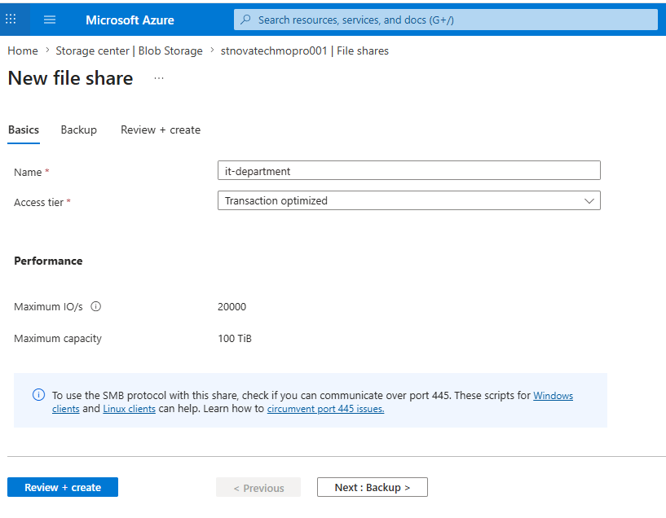

To change the quota, click on the three (…) at the right hand corner of the screen
